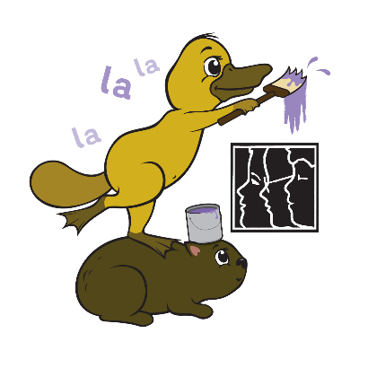
Foundation 2022

Dates to Remember
Transition Packs Distributed
Week beginning Monday 11th October
Zoom Sessions for students
Friday, 29th October ‘21 (A-K 9.30 -9.50am)
(L-Z 10.30 – 10.50am)
Friday, 5th November ‘21 (A-K 9.30 -9.50am)
(L-Z 10.30 – 10.50am)
Friday, 12th November ‘21 (A-K 9.30 -9.50am)
(L-Z 10.30 – 10.50am)
Mikilyi Classroom Blog Launched
Wednesday 3rd November ‘21
Parent Information Session (Zoom Meeting)
Thursday, 18th November ’21 6.30 – 7.30pm
Onsite Sessions
Monday, 22nd November ‘21 9.30 – 10.30am
(Meet Buddies)
Tuesday, 7th December ’21
12.00 -12.45pm (A-K)
12.15 – 1.00pm (L-Z)
Information about 2022
Mailed during week beginning Monday, 13th December ‘21

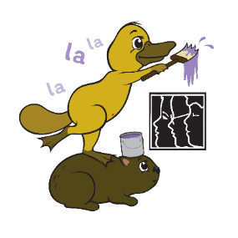
Foundation 2022

Dates to Remember
Transition Packs Distributed
Week beginning Monday 11th October
Zoom Sessions for students
Friday, 29th October ‘21 (A-K 9.30 -9.50am)
(L-Z 10.30 – 10.50am)
Friday, 5th November ‘21 (A-K 9.30 -9.50am)
(L-Z 10.30 – 10.50am)
Friday, 12th November ‘21 (A-K 9.30 -9.50am)
(L-Z 10.30 – 10.50am)
Mikilyi Classroom Blog Launched
Wednesday 3rd November ‘21
Parent Information Session (Zoom Meeting)
Thursday, 18th November ’21 6.30 – 7.30pm
Onsite Sessions
Monday, 22nd November ‘21 9.30 – 10.30am
(Meet Buddies)
Tuesday, 7th December ’21
12.00 -12.45pm (A-K)
12.15 – 1.00pm (L-Z)
Information about 2022
Mailed during week beginning Monday, 13th December ‘21

