

WESTMEADOWS PRIMARY SCHOOL
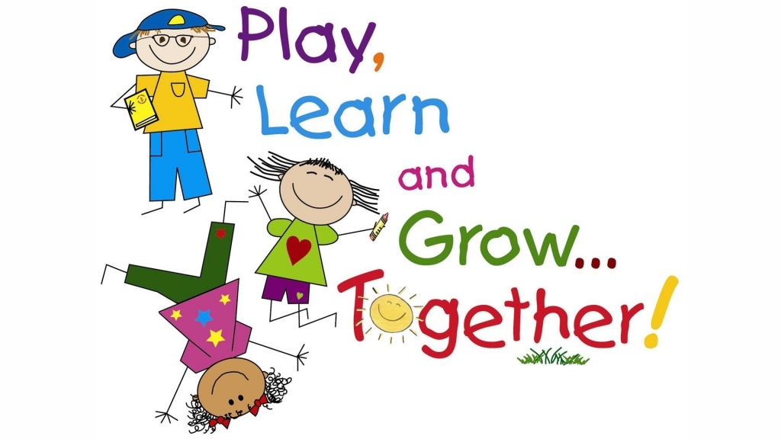

FOUNDATION 2022
PARENT INFORMATION
PARENT INFORMATION
FOUNDATION 2022

WELCOME TO WESTMEADOWS PRIMARY SCHOOL
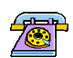
TELEPHONE NUMBER: The school telephone number is 9309 4350.

ENQUIRIES
If at any time, there is something you would like to know about the school, or your child’s progress, please feel free to speak to the class teacher or Principal.
Principal: Ms Jane Donaldson
Acting Asst Principal: Ms Sarah Greig
Business Manager Mrs Marisa Petersen
Secretary: Mrs Maree Naismith

FIRST DAY REQUIREMENTS
On the first day your child should bring:
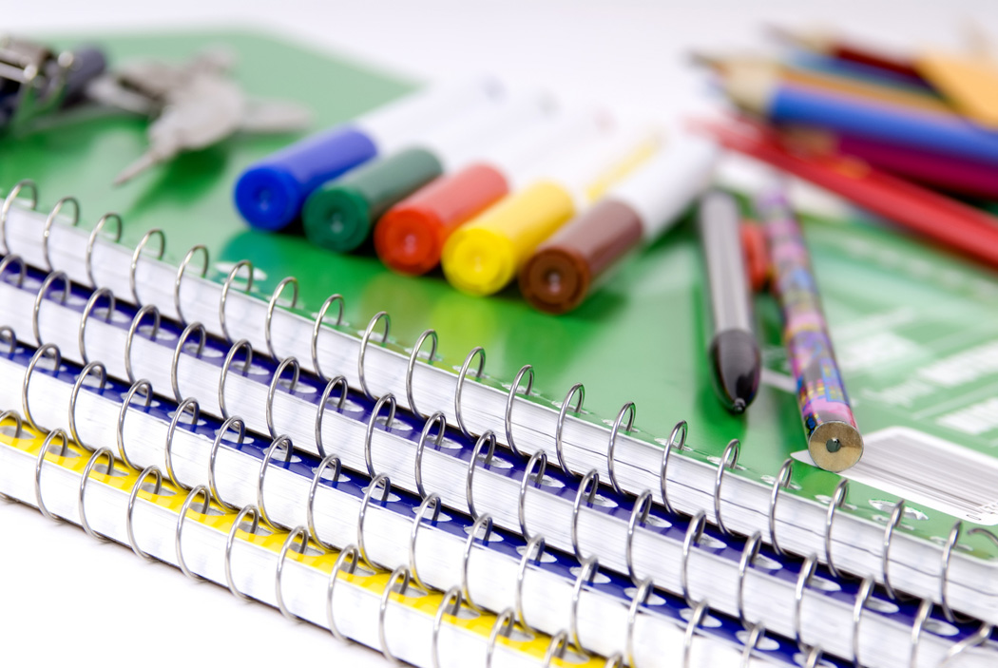
- a spare pair of underpants (to be kept in school bag throughout year)
- school hat
- play lunch
- art smock

  - book pack will be distributed on the 1st day of school in the clasroom

TERM DATES
FOUNDATION CHILDREN WILL COMMENCE SCHOOL ON MONDAY 31ST JANUARY
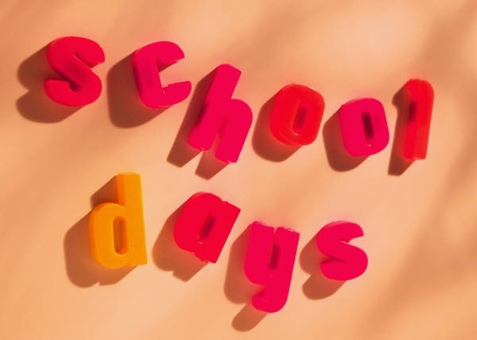
Term 1 Monday 31st January to Friday 8th April
Term 2 Tuesday 26th April to Friday 24th June
Term 3 Monday 11th July to Friday 16th September
Term 4 Monday 3rd October to Tuesday 20th December

SCHOOL HOURS
Please make sure that your child arrives on time. Lateness is upsetting for the child involved and unsettling for the teacher and the whole class. Parents bringing their children to school after 9.00am are requested to report firstly to the main office, to receive a late slip. This ensures smoother communication for class teachers and reinforces our procedures for pupil security.

DISMISSAL TIMES
Week 1: 1.00pm on Monday 31st Jan, Tues 1st Feb, Wed 2nd Feb, Thurs 3rd Feb
& Fri 4th Feb

Week 2- Week 5: 3.30pm on Monday , Tuesday , Thursday & Friday
*There is no school on Wednesdays due to Individual Testing.

From Monday 7th February until Friday 11th March, 2022, Foundation children will be attending school on Monday, Tuesday, Thursday and Friday of each week from 9.00am until 3.30pm. Children WILL NOT be attending on WEDNESDAYS during this time, due to Foundation Individual Testing.

From Tuesday 15th March 2022 Foundation children will attend school every day from 9.00am until 3.30pm.
Monday 14th March is Labour Day (Public Holiday)
BEFORE COMING TO SCHOOL

WHAT PARENTS SHOULD DO:
- Show their child the safest way to school.
- Teach the child his/her road rules - especially the use of the School Crossing.
- LABEL ALL CLOTHING AND POSSESSIONS CLEARLY
- Talk to the child about starting school. School is an enjoyable place.
- Talk to the child about the danger of talking to and accepting rides from
strangers.

PARENT INVOLVEMENT AND ORGANISATIONS:
Parent involvement in school programs and activities is a feature of Westmeadows Primary School. Parents may become involved in:
- Reading/ Writing/ Mathematics (activity sessions) programs
- School sports
- Attending excursions
- Working Bees
- Canteen duties
- Parents’ Club
- Assistance with fundraising
- School Council
- Computer Assistance.
If you are interested in assisting with school activities, you will need to attend our Parent Helpers Training Session, which will be held beginning of Term 1. The school will notify all parents of the date.
Please Note – This session is compulsory if you wish to assist in the classroom.

Help yourself! Help your children! Help the school!
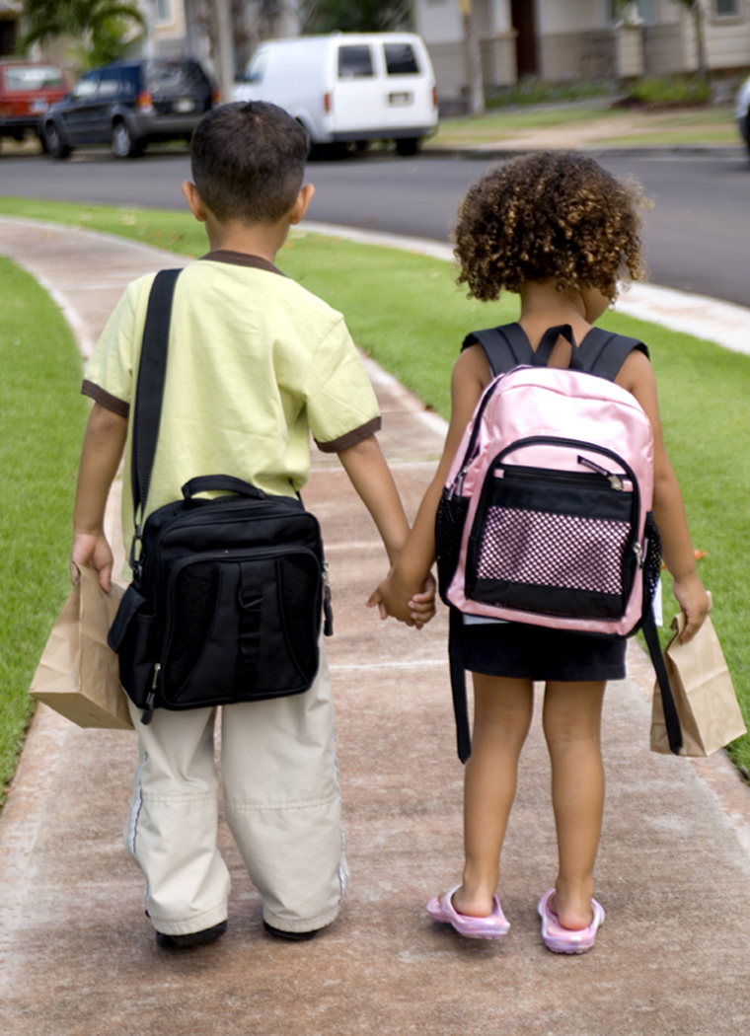

POSITIVE PLAN TO ASSIST YOUR CHILD
The start of school is an exciting time
- New teacher
- New faces
- New buildings
- New play areas
- New classroom
- New, books, pencils, art materials, sport balls, readers, library books
- New Uniform
- New canteen

During the Christmas holidays, talk positively about the new environment.
Example : You will have a lovely time with your teacher………, and you will
make new friends to play with, and learn new and exciting things.

First month (at least) tell them
- Every day is a good day
- Every day is a fun learning day
- Greet your child with a happy SMILE when you collect him/her.

10 tips to a good start
- Ensure your child has practical skills, such as being able to take off a jumper or opening their lunchbox.

- Share your excitement but not your anxieties.

- Punctuality, which parents need to understand as well.

- Help with friendships, by meeting other families after hours and inviting other children to play.

- Be interested but don’t push. After school, the last thing a child may want to do is talk about it.

- Expect them to be very tired. Keep the rest of their life as close to routine as possible.

- Be on time for pick up and provide a cool drink and healthy carbohydrate snack such as a sandwich.

- Help them develop organisational skills and keep track of possessions.

- Integrate home and school life, showing them the value of what they are learning.

- Don’t compete. Understand children develop at different rates and how fast they know their alphabet won’t determine their entire future.

- Enjoy this new stage in your life. Your child will be enjoying their new school.
- Children will need to be able to go to the toilet by themselves and undo and do up any buttons and zips, flush the toilet/urinals, wash their hands, manage the taps.

A HEALTHY, HAPPY CHILD IS A GOOD LEARNER


TALK about what you see and do with your child

- Name people and things
- Describe what they are doing or feeling
- Sing songs and nursery rhymes – in any language!


LISTEN to what they think about things

- Ask them What do you think about …….?
What happens if ………….?
How many times can ………….?

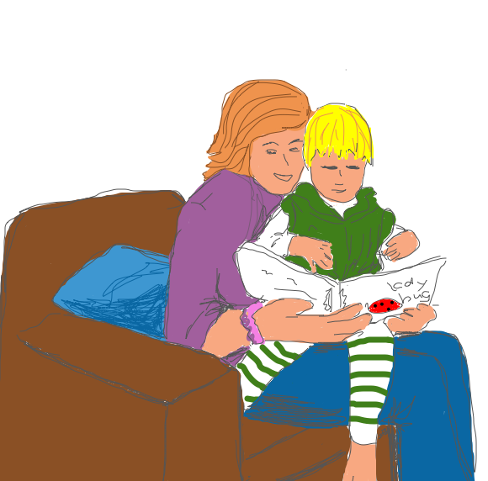
READ with your child
- Try reading The Very Hungry Caterpillar by Eric Carle with your child. Ask what foods they see in the book. Go through it again, looking at each picture and have them decide whether it is an everyday, healthy food or a sometimes, unhealthy food.

EXPLORE the world around you

- Eye Spy – “Eye spy, with my little eye, something that begins with ….”
Introduce letters and their sounds, or simply use colours you can see. Help the children notice things that begin with that letter i.e. “what can we see that begins with ‘m’ – a mirror, a mail box, a monkey – yes it’s the monkey!”

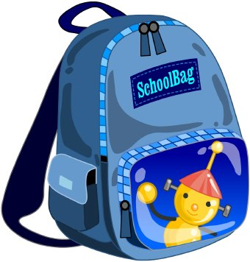
DO encourage children to do things for themselves.
- Simple everyday tasks such as carrying their own bag, opening their lunchbox and getting dressed in the morning.
- Try building a tower using paper cups. If it falls, try again. Measure how tall the tower is and count how many cups are there.


